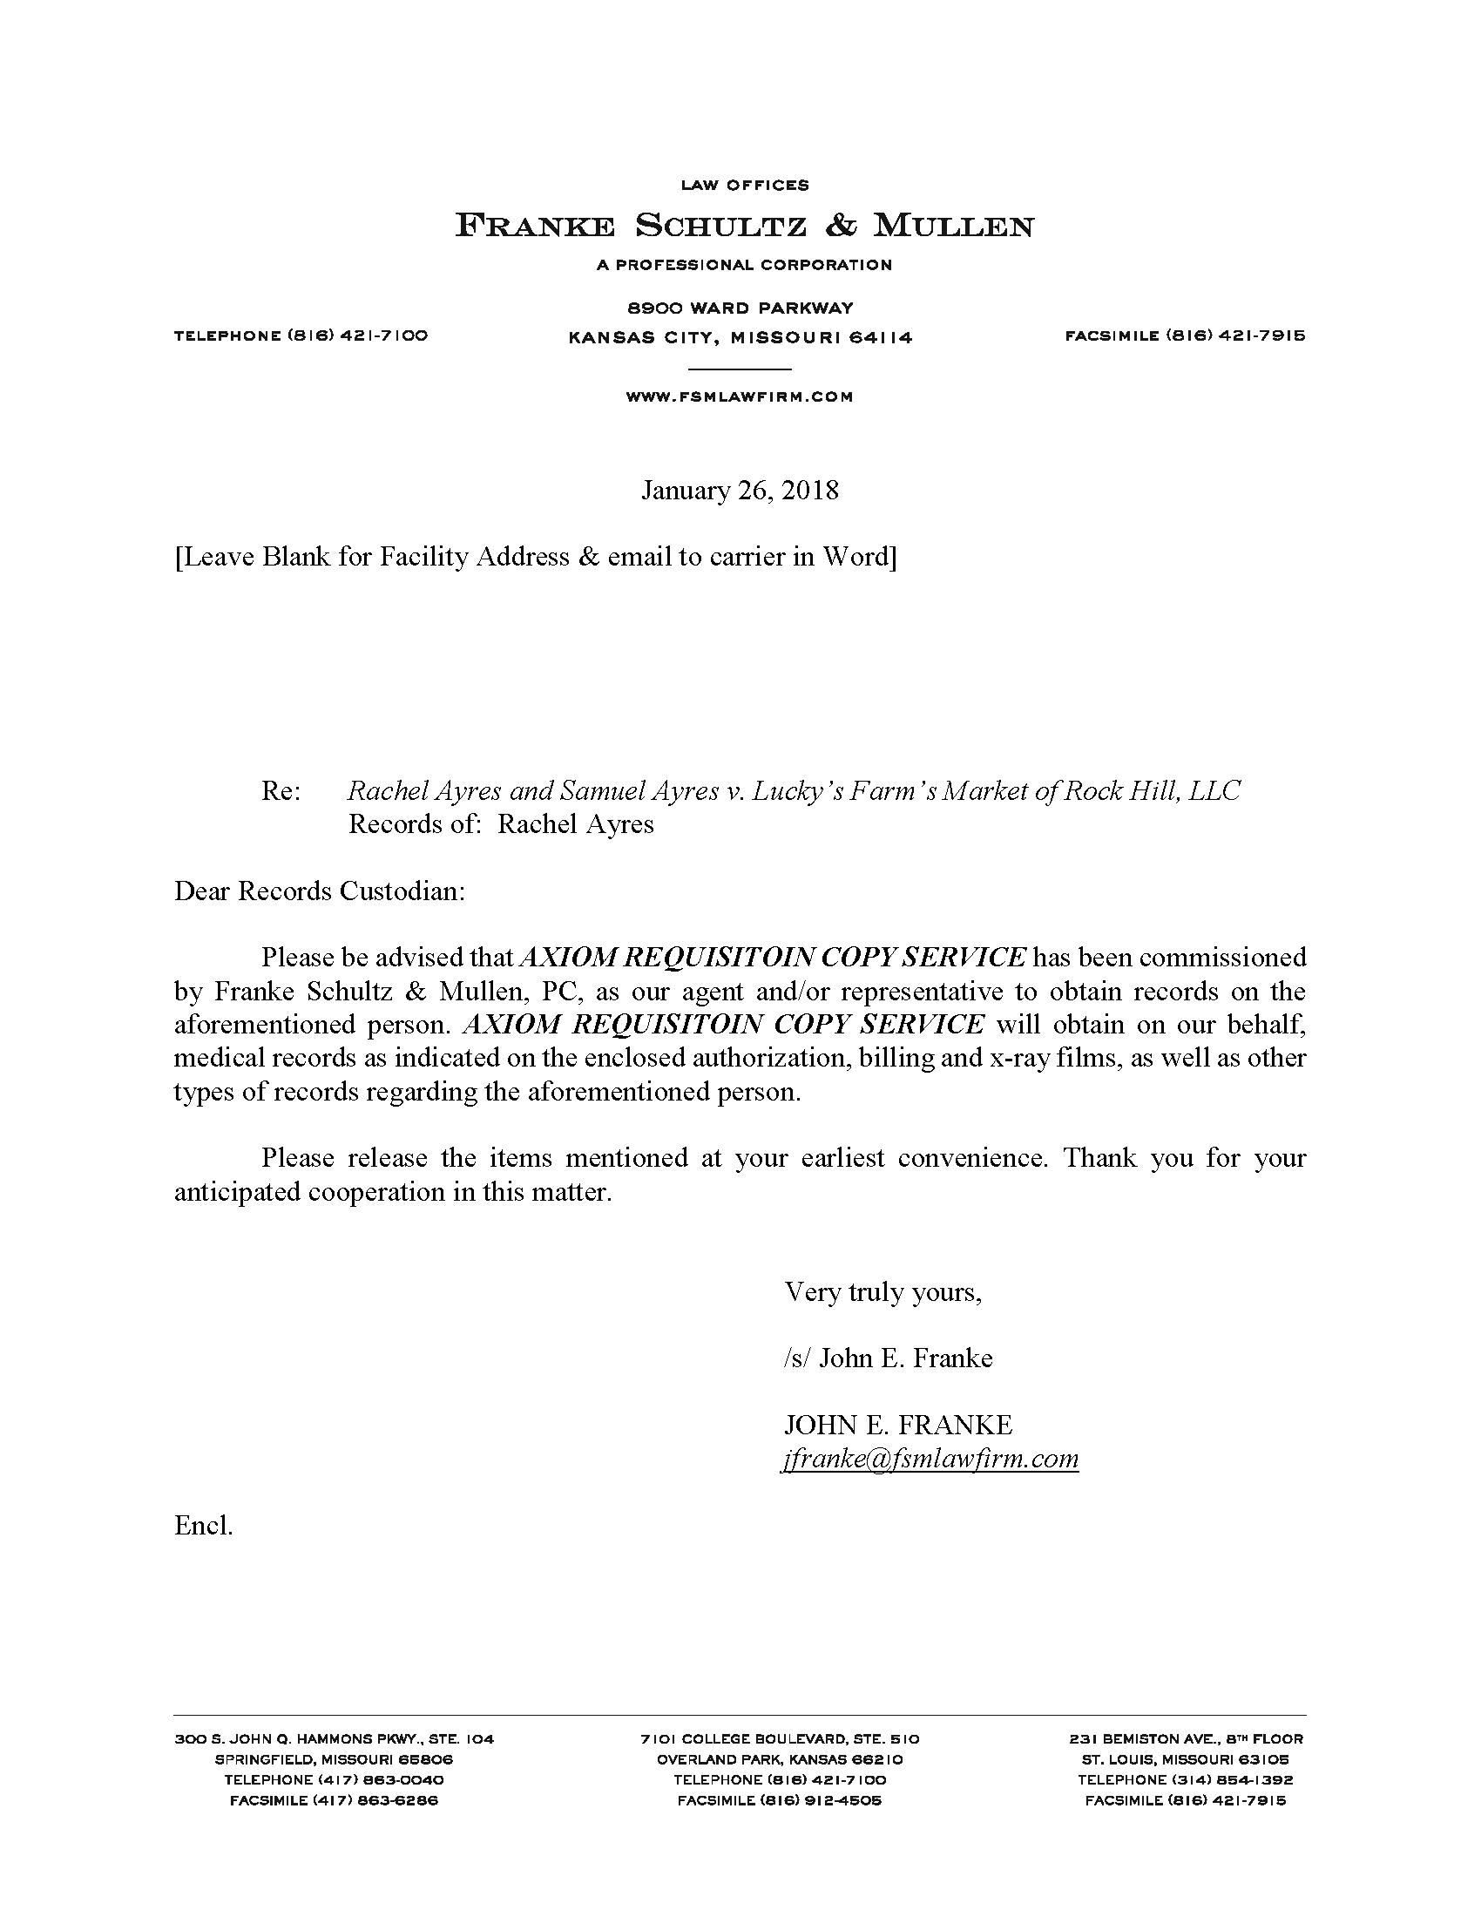
University of Michigan Hospital and Health Center
2901 Hubbard Street Room 2722
Ann Arbor, MI 48109-0000

Batman

